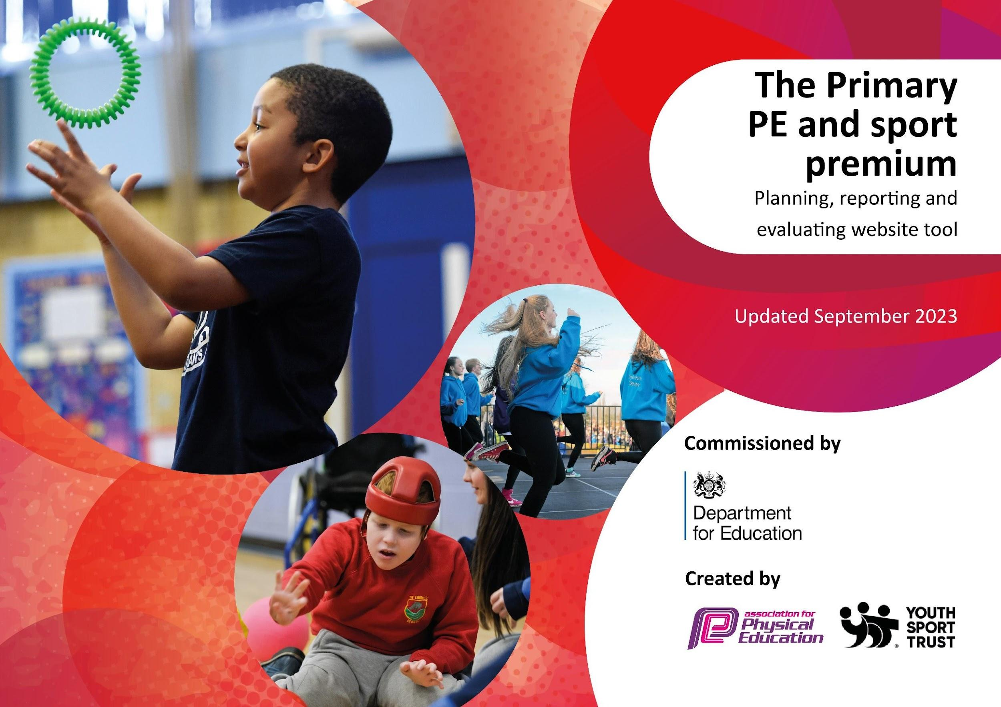

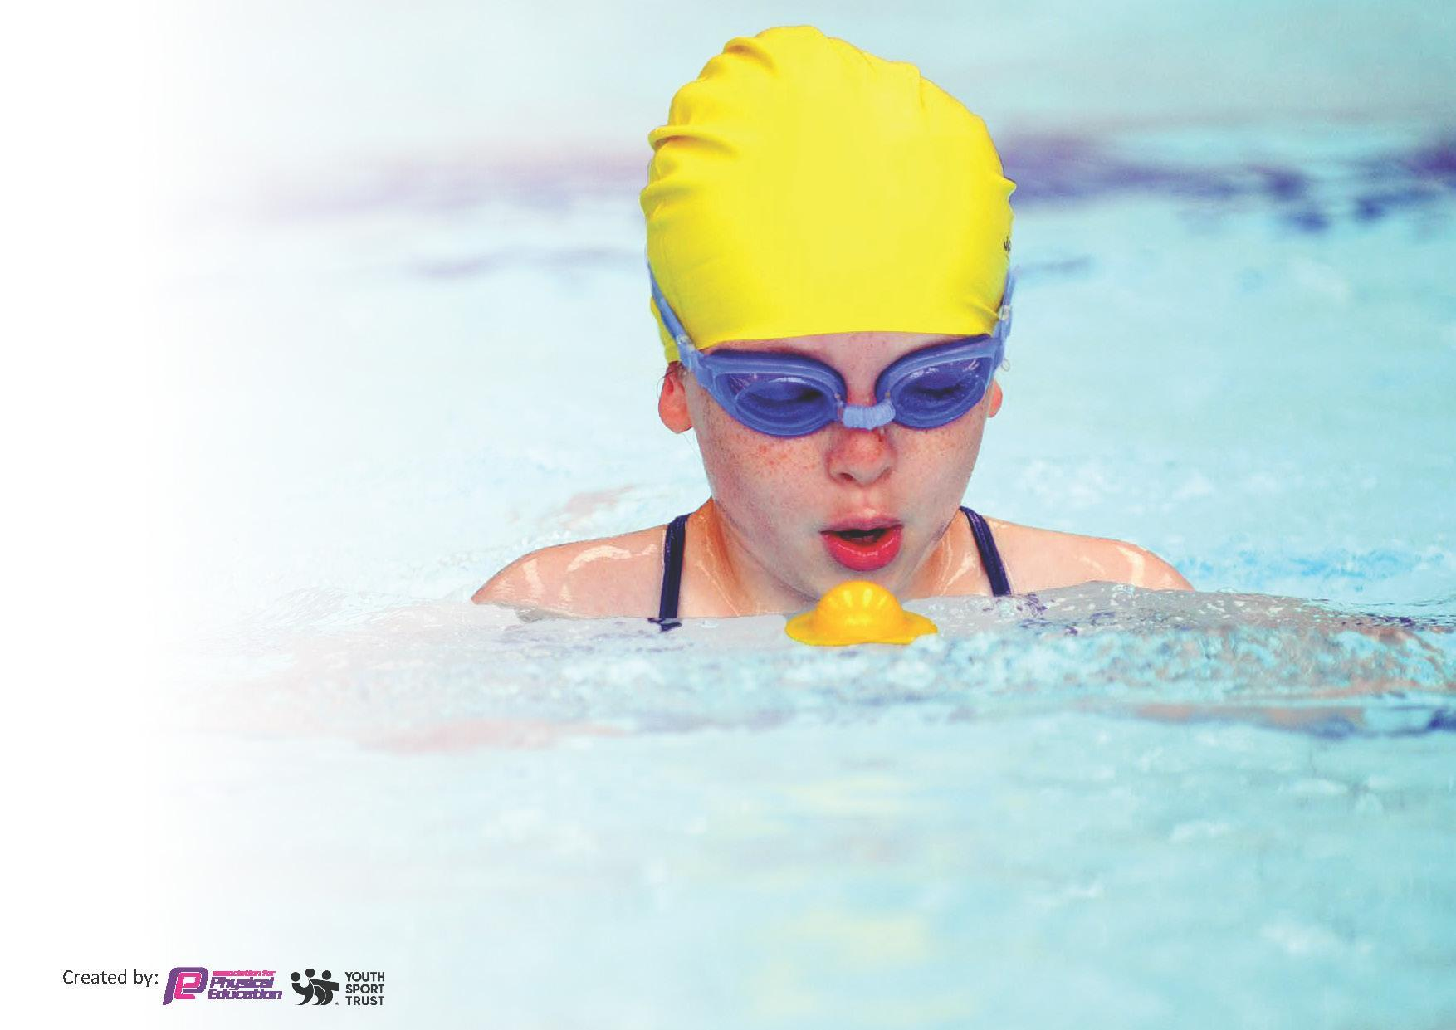
This template can be used for multiple purposes:
by:
- It enables schools to effectively plan their use of the Primary PE and sport premium
- It helps schools to meet the requirements (as set out in guidance) to publish information on their Primary PE and sport premium
- It will be an effective document to support Ofsted inspections enabling schools to evidence progress in Physical Education (PE) and evidence swimming attainment, which forms part of the PE National Curriculum. We would recommend schools consider
the Intent, Implementation and Impact of any spend, as examined within the Education Inspection Framework.

It is important that your grant is used effectively and based on school need.

Schools must use the funding to make additional and sustainable
improvements to the quality of the PE, School Sport and Physical Activity (PESSPA)
they offer. This means that you should use the Primary PE and sport premium to:

- Build capacity and capability within the school to ensure that improvements made now will benefit pupils joining the school in future years
- Develop or add to the PESSPA activities that your school already offers.

The Primary PE and sport premium should not be used to fund capital spend projects; the school’s core budget should fund these. Further detail on capital expenditure can be found in the updated Primary PE and sport premium guidance.

necessary that spending has to meet all the key priorities, you should select the priorities that you aim to use any funding towards.

Although completing this template is not a requirement for schools, schools are required to publish details of how they spend this funding. Schools must also outline what the impact this funding has had on pupils’ PE and sport participation and attainment and how any spending will be sustainable in the future. All funding must be spent by 31st July 2024.

The Department for Education has worked closely with the Association for Physical Education (afPE) and the Youth Sport Trust (YST) to develop this template and encourages schools to use it. This template is an effective way of meeting the reporting requirements of the Primary PE and sport premium.
Review of last year’s spend and key achievements (2022/2023)

We recommend you start by reflecting on the impact of current provision and reviewing your previous spend. £19160 was received in the academic year 2022/23

Activity/Action | Impact | Comments
Targeted groups of children (PP and ELSA) taking part in competitions  Sports coach has delivered high quality PE lessons to pupils across the school.  Pupils have attended and participated within a wider range of competitions.  Sports Leaders have supported the school in promoting the profile of sports and PE across the school.  Engaged a wider range of children in afterschool clubs through providing clubs of their interests. | A wider variety of children participating in physical activities and sporting competitions.  Teachers feel more confident team teaching PE. The children have benefitted from a range of high quality PE lessons.  The children in KS2 have thoroughly enjoyed competitions within school and outside of school. We have encouraged participation through updating a PE display and social media with sporting events to show case the variety of events taking place.  Sports leaders have supported at break times and lunchtimes encouraging children in KS1 to participate in physical activities. They have supported with communication skills, teamwork and motor skills.  Many children signed up to after school club based on their sporting interest. This also supported with sporting competitions. | The children enjoyed participating in a range of different sporting events and enjoyed competing with other schools.  This has particularly been helpful in promoting sporting events in school and encouraging more children to participate in physical activities.  This has been very successful this year and the sports leaders have also been involved in other sporting events across the school such as sports day.

Review of last year’s spend and key achievements (2022/2023)

We recommend you start by reflecting on the impact of current provision and reviewing your previous spend. £19160 was received in the academic year 2022/23

Activity/Action | Impact | Comments
- Providing opportunities to KS2 children at lunch times and break times. Sports coach to offer similar sporting opportunities to KS1 children.  - To have access to equipment to use during break time and lunchtime. Equipment to be stored in the outside shed for access.  - Providing children with equipment to use at break time and lunch time to encourage active break/ lunch.  £1000 spent here  - Offer a range of extracurricular activities for pupils from EYFS to Year 6.  - To continue to ask Children about extra curricular activities they would prefer and new opportunities are being offered.  £20000 spent on the coach.  - Quality PE lessons provided for pupils in PE lessons  - Sports coach supports teachers using the new PE scheme successfully. Sports coach is supported with team teaching and makes sure equipment is up to date and available.  - Swimming coaching and water safety instruction provided for pupils.  - Qualified instructors used to teach pupils a range of strokes and water safety skills.  - Sports Leaders will develop their leadership skills and independence.  - Sports leaders to continue to carry out break and lunch time activities with children in Key Stage 1. Sports leaders to use the new PE scheme to implement break time and lunch time activities.  - Sports leader to continue to take more ownership of a range of sport activities taking place across key stage 1 and sports day.  - High profile achievements in classes with certificates where appropriate.  - To celebrate sporting achievements in school classes and on different platforms awarding trophies and certificates as appropriate.  - Sports coach will support the class teacher with delivering high quality PE lessons to pupils. This will increase the confidence, knowledge and skills of staff in teaching PE.  - Sports coach to continue to support the class teacher with delivering high quality PE lessons to pupils. This will increase the confidence, knowledge and skills of staff in teaching PE and sport. Sports coach to work with new members of staff and up level their skills in specific sporting areas.  - Embed the fundamental skills through Get Set for PE scheme and Big moves programme offered throughout KS1.  - To continue the Big moves programme with the new intake of EYFS children.  - Sport Coach will provide the subject knowledge required to skilfully teach some areas of The National Curriculum requirements for PE.  - To continue to provide the subject knowledge required to skilfully teach some areas of The National Curriculum requirements for PE. Sports Coach to work with teachers providing a new P.E. scheme.  - To continue to offer a variety of clubs with a focus on Pupil Premium children and SEN children.  - Pupil Premium children continue to have first priority to select after school clubs on a half-termly basis. We are aiming to achieve 10% more pupil premium children to take part extra-curricular activities. This is going to be monitored throughout the year. Consistent communication with parents every half term.  £1000 spent here  - Encourage a range of children in after school clubs through providing clubs of their interest in year groups.  - To continue to build on a wide range of after school clubs through external providers and school staff.  - To offer pupils with a wide range of competitive level 1, 2 and qualifying competitions through PE lessons with the emphasis on inactive children and Pupil Premium children.  - To provide pupils with a wide range of competitive level 1, 2 and qualifying competitions through PE lessons with the emphasis on inactive children and Pupil Premium children. | In total 14 Year 5 and 6 pupils helped support KS1 children in play, learning fundamental skills such as throwing, catching, kicking and embedding rules of games such as football. KS1 children also played a variety of sporting games taken from our PE scheme with equipment to help them communicate and take turns.  Sports coach carried out a range of activities with all children across Key Stage 2. Activities included:  Dodgeball, Basketball, Football, Tag rugby, Cricket  Teachers promoted the importance of swimming and water safety through a range of quizzes, lessons and assemblies as well as through swimming lessons.  Sports leaders have carried out a range of sporting activities with KS1 children at break times and lunchtimes. They have taken on more ownership with games and utilised the PE scheme for a range of games. The sports leaders promoted and encouraged all children on sports day through the support of the sports coach.  Children in Year 3 and Year 6 have benefited from lessons this year.  The Children have been rewarded with certificates, trophies. They have also been celebrated in whole school assemblies.  Sports coach supported the class teacher with delivering high quality PE lessons to pupils. This increased the confidence, knowledge and skills of staff in teaching PE and sport.  Children in EYFS participated and were assessed in the 12 Big Moves programme. Any next steps were forwarded to parents through communication and tasks were set at home to follow up.  Sport Coach provided the subject knowledge required to skilfully teach some areas of The National Curriculum requirements for PE. Sports Coach worked with teachers teaching and embedding PE scheme.  Pupil Premium successfully had first priority when signing up to clubs on a half term basis. We met our aim to achieve 10% more pupil premium children to take part extra-curricular activities. This was monitored throughout the year by consistent communication with parents every half term.  After school clubs were ran successfully through external providers and school staff.  Sports coach carried out break time and lunch time activities with the children in Key Stage 2 with a focus of Pupil Premium children.  Activities included:  Year 3-6 dodgeball  Key Stage 2 cross country  Year 3-6 athletics  Year 3/4 boys and girls football.  Year 5/6 boys and girls football.  Key Stage 2 boccia and kurling  This has been promoted throughout the school year using the school games and values. We have been able to take part in several competitions including, Tag Rigby and football. | Sports leaders enhanced break times and lunch times by giving the children an opportunity to play a wide variety of games. More KS1 children were active during this period and learned how to communicate and work as a team.  The children thoroughly enjoy participating in competitions within school and competing with each other. They understand the school ethos and the importance of taking part in a wide range of activities. Due to the amount of different activities on offer, all children were able to participate and found a new passion for sports.  Sports leaders were a huge success last year with a large take-up of children supporting games and activities during break and lunchtimes. This helped developed sports leaders' confidence and understanding of leading and supporting other children. They developed their communication skills and helped organise key events at school such as sports day.  This has helped promote different sports across school and embedded the schools ethos and values when it comes to taking part in sports.  The children had a wide variety of sporting activities to choose from and work with different staff members.  Alongside the other sporting activities and competitions, this allowed more children to participate in sporting activities and events.  New lead teacher next year will lead to more opportunities.

Key priorities and Planning for academic year 2023-2024
This planning template will allow schools to accurately plan their spending. Total funding in 2023-2024 academic year is £19, 160

Action – what are you planning to do | Who does this action impact? | Key indicator to meet | Impacts and how sustainability will be achieved? | Cost linked to the action
To review lunchtime routines and provide sporting opportunities to KS2 children at lunch times using the new zones within the playground.  Sports coach to develop and expand sporting opportunities to children in KS2 and extend opportunities for games and sporting events to children in KS1 and EYFS during lunch times.  Quality PE lessons provided for pupils in PE lessons  Teachers and sports coach to promote the importance of swimming and water safety. | Lunchtime supervisors and sports coach.  All KS2 children and we would like to open up these opportunities to KS1 children to participate in sporting activities with sports coach.  All children as they will take part.  Sports coach as he will be leading the activity.  All children across the school will have quality first PE lessons  All teaching staff  All teachers and the sports coach who will work closely with the swimming instructor to reinforce this to all children. | Key indicator 1 - To have access to equipment to use during break time and lunchtime. Equipment to be stored in the outside shed for access.  Providing children with equipment to use at break time and lunchtime to encourage active break/ lunch.  Key Indicator 4 – Broader experience of a range of sports and activities offered to all.  Key indicator 3:Sports coach to continue team teaching with teachers  Key indicator 3: Sports coach to work with new members of staff and up level their skills in specific sporting areas.  Key indicator 1 and 2: PE lessons offer a range of physical activities and ensure equipment is up to date and available.  Key indicator 2 and 3: Qualified instructors used to teach pupils a range of strokes and water safety skills. Transport to and from the leisure centre provided. Staff to have undergone water safety induction and swim test for teaching staff and TA’s in year 3. | More children involved in physical activity and encouraged to participate in sporting events.  More children participating in sporting activities and engagement in sports.  All having the confidence and knowledge of understanding and teaching a PE lesson.  Teachers understand the importance of daily exercise and physical activity.  All children learning to swim in school and staff undergoing induction to ensure they are confident in reinforcing the importance of swimming and water safety to children. | £25000 Sports Coach cost  (see above, costing for additional adult support)  (see above, costing for additional adult support)

Year 5 and 6 Sports Leaders to develop their leadership skills, independence and confidence  To aim for high profile achievements in classes and across the school with certificates where appropriate.  Sports coach will support the class teacher with delivering high quality PE lessons to pupils.  To embed the fundamental skills through Get Set for PE scheme and Big moves programme offered throughout KS1.  Sport Coach will enhance and strengthen their subject knowledge to skillfully teach areas of the National Curriculum requirements for PE.  To offer a variety of clubs with a focus on Pupil Premium children and SEN children.  Encourage a range of children in after school clubs through providing clubs of their interest in year groups.  To continue to offer pupils with a wide range of competitive level 1, 2 and qualifying competitions through PE lessons with the emphasis on inactive children and Pupil Premium children.  To strengthen and promote the school ethos and values; encouraging pupils to participate as a school team. This will increase participation in competitive sports and raise the profile of PE within school and outside of school. | Pupils in Year 5 and 6  Children in KS2 as they will be participating  sporting coach as he will be leading activities.  Sports coach and teacher as they will be working closely together to support teaching of PE lessons. This will also impact the children as it will provide them with high quality PE lessons.  All pupils as they will be taught fundamental skills.  The sports coach.  Impact on all children (especially PP children and SEN children) who do not have opportunities outside of school to partake in clubs that are fitness related.  Sports coach and teaching staff  KS1 and KS2 children participating in the clubs  All children across the school, with a focus on Pupil Premium children, SEN children and inactive children.  All children  Teaching staff, sports coach and teaching support staff embedding and promoting the school’s values and ethos. | Key Indicator 2 and 4: Sports leaders to carry out break and lunchtime activities with children in KS1 and children in Year 3, particularly supporting them with group games such as football. Sports leaders will continue to use the PE scheme to implement break time and lunchtime games and activities with support from the sports coach and PE leads.  Key indicator 2 and 4: Children to continue to be rewarded with certificates and trophies to recognise their achievements in school and extend their achievements across different platforms to raise their profile.  Key indicator 2 and 3: Sports coach to continue to support the class teacher with delivering high quality PE lessons to pupils using the Get Set 4 PE framework. Sports coach to work with new members of staff and up level their skills in specific sporting areas.  Key indicator 1:To enhance the Big moves programme with the new intake of EYFS children and using the fundamental skills from PE scheme  Key indicator 2: the engagement of all pupils in regular physical activity  Key indicator 2 and 3: increased confidence, knowledge and skills for PE and teaching staff to deliver high quality lessons. An understanding of the importance of physical education, school sport and physical activity across the school.  Key indicator 4: Pupil Premium children continue to have first priority to select after school clubs on a half-termly basis. We are aiming to achieve 10% more pupil premium children to take part extra-curricular activities. This is going to be monitored throughout the year. Consistent communication with parents every half term.  Key indicator 2 and 4: To continue to build on a wide range of after school clubs and to increase the number of children participating in physical activity.  Key indicator 4 and 5: an increased participation in sport related competitions and a broader range of sports and activities offered to all pupils.  Key indicator 2, 3, 4 and 5; To continue to promote the school ethos and values; encouraging pupils to participate as a school team encouraged by all staff and sport coach. To offer a wide variety of sport games and events for all abilities and encouraging school values through learning animals. | Build in confidence for children in year 5 and 6 to support group games, communication and building their independence skills.  More children wanting to participate in sporting events and get involved in a wide variety of sports games.  This will increase the confidence, knowledge and skills of staff in teaching PE and sport.  More pupils achieving their daily physical activity goal and building on their fundamental skill set for sporting activities.  A secure understanding of the National Curriculum and secure subject knowledge to ensure areas highlighted in the NC are taught effectively to all children.  More Pupil Premium and SEN children joining after-school clubs and positive impact on increasing fitness skills in a variation of areas in addition to PE lessons within school.  Increased number of children participating in physical activities  More children involved in sport-related competitions and an increase in opportunity for children who are inactive or do not compete in outside of school sporting activities.  All staff members to embed the school’s values and ethos when participating in sporting competitions, PE lessons and extra-curricular activities. | (see above, costing for additional adult support)  (see above, costing for additional adult support)  (see above, costing for additional adult support)  (see above, costing for additional adult support)

Key achievements 2023-2024
This template will be completed at the end of the academic year and will showcase the key achievements schools have made with their Primary PE and sport premium spending.

Activity/Action | Impact | Comments
Sports leaders providing games and additional support at lunch times.  The sports coach supporting and providing additional games and sporting opportunities for all children across the school.  The sports coach providing sporting competitions across KS2 during lunchtimes.  A range of extra curricular activities provided after school by staff to engage more PP and SEN children into being active. | In total around 14 Year 5 and 6 pupils helped support KS1 children during lunchtimes by teaching fundamental skills such as ball catching, ball throwing, ball kicking and embedding game rules into activities. Children were encouraged to play a wider variety of games using games cards from our PE scheme.  This has encouraged more children to participate in sports coach led games and activities. It has encouraged children across KS2 to embed rules in games such as football and basketball by the sports coach refereeing these games.  The sports coach has carried out a variety of competitions during lunch times. This has been hugely successful as there has been a large intake of children across KS2. The impact of this is that the children enjoy the competitive nature and teamwork skills that come with this type of activity and the increase in their passion for sporting related activities.  Dodgeball, football, basketball, cricket, Tag rugby  There has been a variety of opportunities and clubs for PP and SEN children to participate in provided by the sports coach and external companies including Leicestershire Cricket, Leicester Tigers. | Resulted in more children across the school engaging in physical activity in their own time and children engaging in a wider range of games and activities that were not previously available to them.  The sports coach has encouraged fair play and embedding game rules across the school when outside at break times and lunch times.  These in school competitions have encouraged all children, including SEN, PP and inactive children, to participate in sporting and competitive level activities alongside the sports coach.  This is been popular amongst SEN and PP children and we are looking to re-doing this next year due to engagement.

Swimming Data
Meeting National Curriculum requirements for swimming and water safety.
Priority should always be given to ensuring that pupils can perform safe self-rescue even if they do not fully meet the first two requirements of the National Curriculum programme of study

Question | Stats: | Further context  Relative to local challenges
What percentage of your current Year 6 cohort can swim competently, confidently and proficiently over a distance of at least 25 metres? | 20% | Our current Year 6 children missed out on swimming lessons during COVID and many do not access swimming outside of school. We have focused on water confidence, water safety and early swimming skills. We also have high numbers of children new to the UK without any experience and high levels of SEND
What percentage of your current Year 6 cohort can use a range of strokes effectively [for example, front crawl, backstroke, and breaststroke]? | 10%

What percentage of your current Year 6 cohort are able to perform safe self-rescue in different water-based situations? | 5%
If your schools swimming data is below national expectation, you can choose to use the Primary PE and sport premium to provide additional top-up sessions for those pupils that did not meet National Curriculum  requirements after the completion of core lessons. Have you done this? | Yes | Several catch up sessions were completed after the SATs for Year 6.
Have you provided CPD to improve the knowledge and confidence of staff to be able to teach swimming and water safety? | No | We currently use the lifeguards and swimming teachers from the Leisure centre to deliver here

Signed off by:

Head Teacher: | Andy Kitchen
Subject Leader or the individual responsible for the Primary PE and sport premium: | Phil Hull
Governor: | Jordan Watson
Date: | 11/7/24

